Sustainability and steaming

What is the definition of sustainability?

The United Nations Brundtland Commission in 1987 referred to sustainability as “meeting the needs of the present without compromising the ability of future generations to meet their own needs”. A succinct statement on the challenge we all face today.

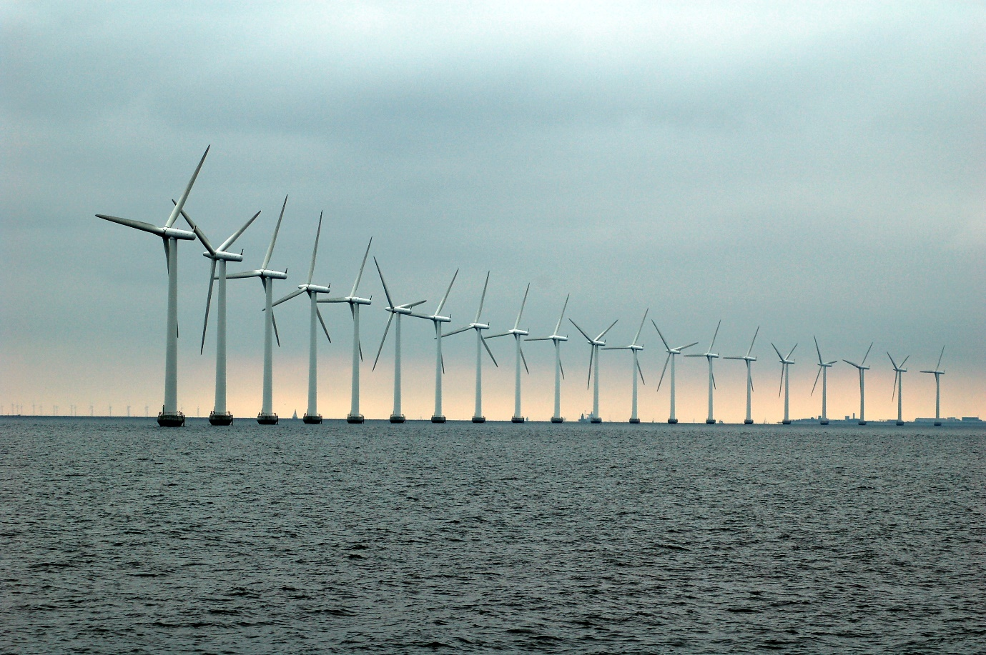

Key sustainability issues

These days we face a variety of sustainability issues across the world and the United Nations have listed 17 ‘Sustainable Development Goals’ with Goal 12 being [‘Responsible consumption and production’](https://www.un.org/sustainabledevelopment/sustainable-consumption-production/).

So with this in mind, what are the key sustainability issues?

Climate change - scientists are predicting temperatures will increase as much as 10 degrees Fahrenheit by the end of the century if the increase in greenhouse gases continues. Unfortunately not all nations are on board with making changes. The [Carbon Brief](https://www.carbonbrief.org/china-is-responsible-for-10-of-human-influence-on-climate-change-study-says/) notes China as accounting for a tenth of all greenhouse gases and aerosols in the atmosphere. China has now overtaken the EU and the US as the world’s largest emitter of CO2 emissions.

Use of natural resources – not just fossil fuels, but areas less talked about such as water and soil.

Waste production – the disposal of non degreadable plastics in our oceans, food waste both from out ‘throw away’ culture but also waste from the [impact of pests](https://www.cambridge.org/core/journals/journal-of-agricultural-science/article/abs/crop-losses-to-pests/AD61661AD6D503577B3E73F2787FE7B2) on food production.

Water pollution – the UN estimates over [80% of wastewater is released in to the environment without adequate treatment](https://unesdoc.unesco.org/ark:/48223/pf0000247553).

Deforestation – trees are important for, amongst a range of things, removing carbon from the atmosphere. According to the [National Geographic](https://education.nationalgeographic.org/resource/deforestation) 2000 years ago 80% of Western Europe was covered in forest. Today it is just 34%. Since 1990 the world has lost 420 million hectares, equivalent to a billion acres. 17% of the Amazonian rainforest has been destroyed over the last 50 years.

Other issues include overfishing, ocean acidification, and air pollution.

How can steaming clothes help sustainabilty?

Four ways:

1. **Steaming clothes helps to preserve the fibres of the fabric so clothes last longer, reducing waste.**   
   The action of a steam iron is to heat and compress fibres. Over time this starts to destroy the fibre structures causing the weave and stitching to break. Steaming on the other hand is a non-aggressive approach, removing creases not by pressure but from a steaming action that relaxes fibres and restores them to their natural state.   
     
   
2. **Steamers are perfect for use on Vintage clothes, helping to prolong the life of clothes.**  
   The growth in demand for Vintage clothing over the last few years has been nothing short of phenomenal. And steamers are a perfect fit with Vintage. The above mentioned non-aggressive approach to fibres helps preserve Vintage clothes to further the sustainability cause.  
     
   Propress has been at the heart of the recycled clothing ‘revolution’ since the 1980’s, working closely with charity shops to transform donated garments in to saleable clothing, and now it’s not just charity shops but also High Street retailers like We Are Cow.  
     
   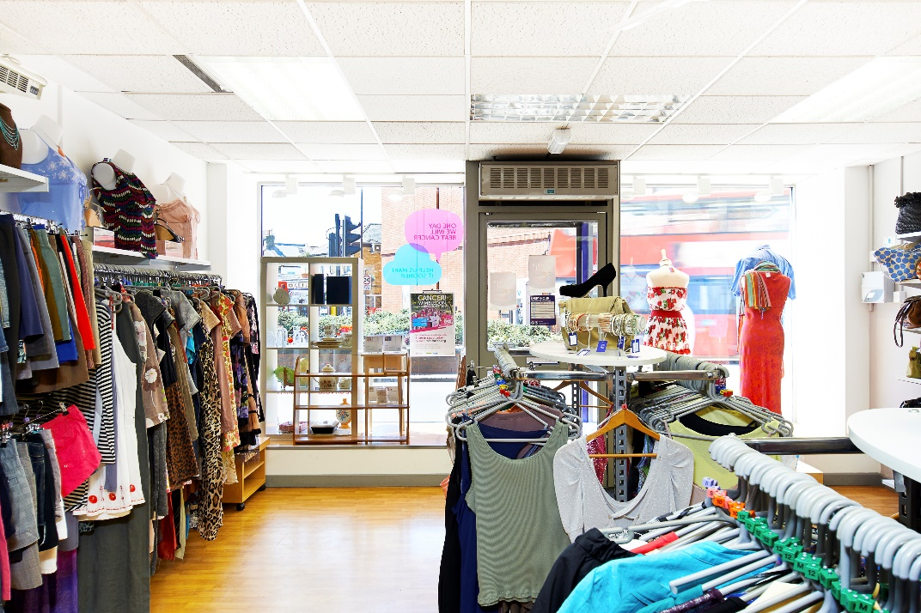
3. **Steaming reduces the need for chemicals, reducing harmful waste products.**  
   The typical list of clothes taken to the dry cleaners includes jackets, suits, dresses, coats, and delicates such as silks and clothes with chiffon and lace. Dry cleaners, however, use chemicals to treat clothes, which can be harmful to the environment. Steaming clothes can delay the visit to the dry cleaner, providing a sufficient freshening and crease removal service in the interim, delaying the use of chemicals harmful to the environment.
4. **Steaming reduces wash loads saving power and chemicals used.**  
   Steaming clothes can effectively delay the need for a wash. The steaming action kills 99% of the odour causing bacteria, so if clothes just need a freshening up before another wear, the steamer can replace the wash, at least in the interim, and less wash loads means less electricity and chemicals used.